**Lab Exercise 8**

**Setting up Maven Build Job in Jenkins**

**Objective:** To set up Maven build job in Jenkins for automating the build process, enabling continuous integration to enhance the software development lifecycle

**Tools required:** Jenkins

**Prerequisites:** You need to have a Jenkins up and running.

Steps to be followed:

1. Log in to Jenkins CI tool and configure Maven freestyle job

**Step 1:** **Log in to Jenkins CI tool and configure Maven freestyle job**

1. Log in to Jenkins using your credentials

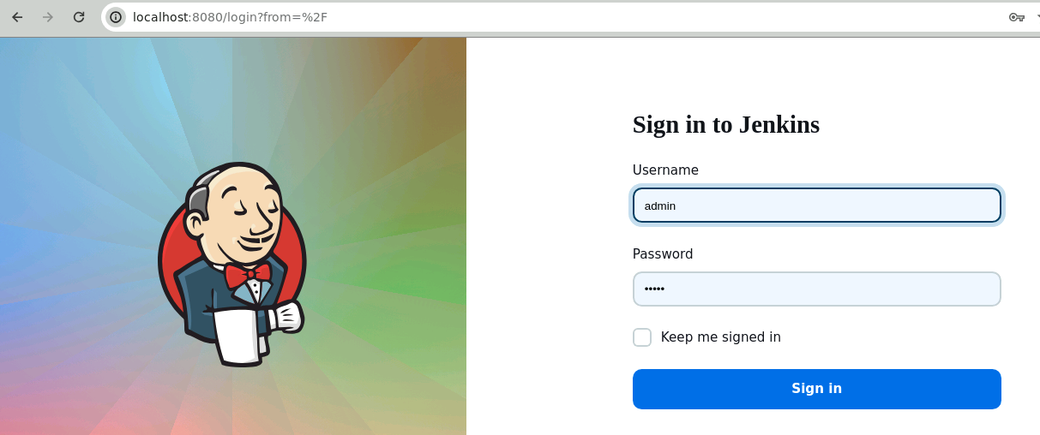

**Note**: The credentials for accessing Jenkins in the lab are Username: **admin** and Password: **admin**.

1. In the Jenkins dashboard, click on **New Item**

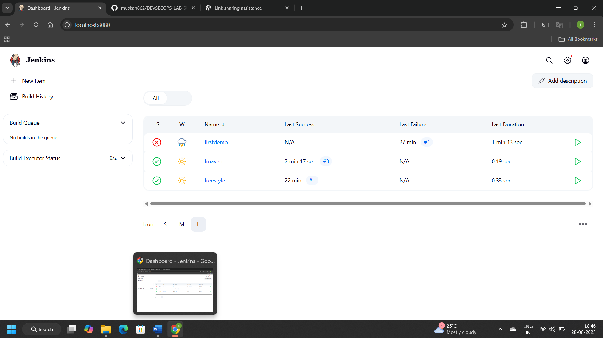

1. Select the **Freestyle project** while creating a Jenkins job, provide a custom job name, and click on **OK**

1. Now, in the Configure page, navigate to **Source Code Management** in the left navigation bar, select **Git**, and then provide the Git repository URL

**Note:** Here, the repository URL is **https://github.com/hkshitesh/DEVSECOPS-MAVEN-REPO.git.**

1. Now, navigate to **Build Steps**, click on **Add build step**, and then select the option **Invoke top-level Maven targets**

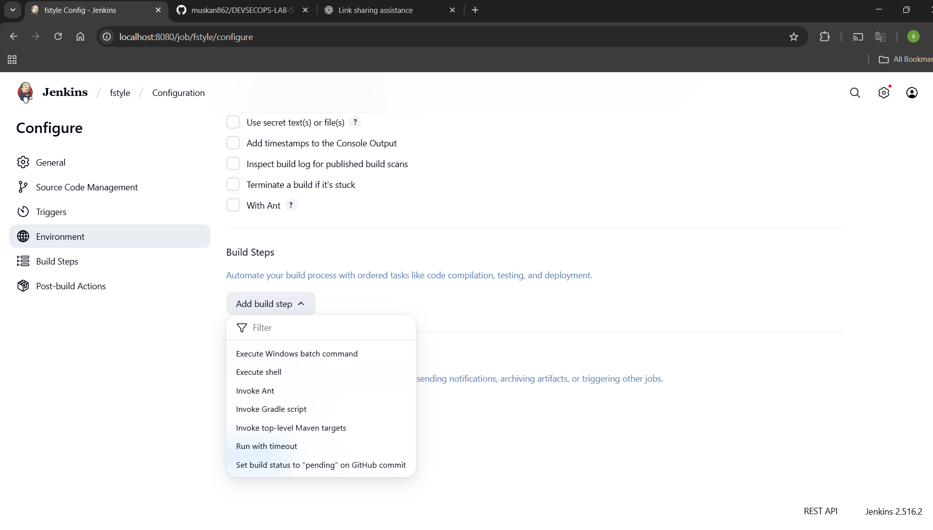

1. Provide clean install under **Goals** section and then click on **Save**

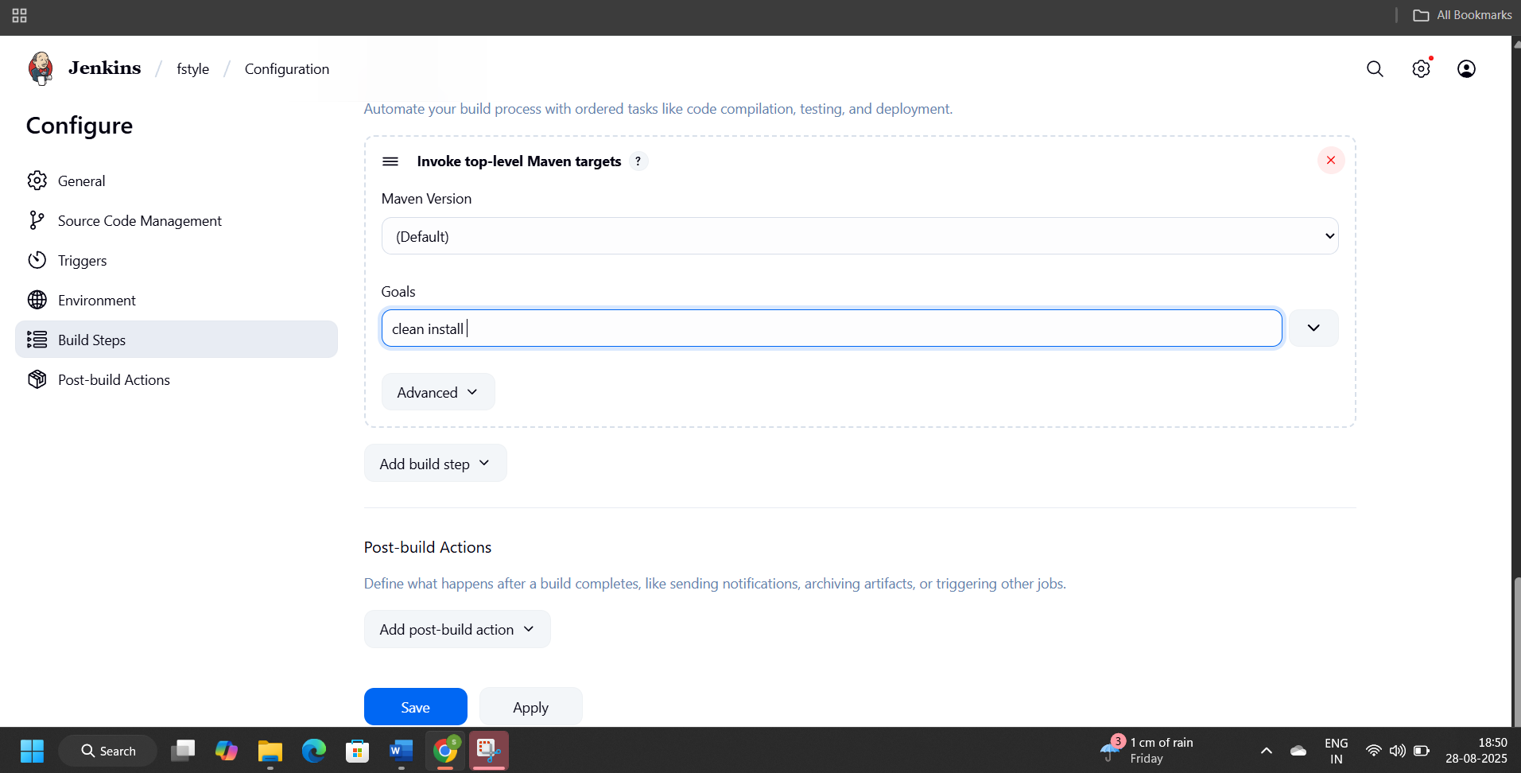

1. You will be navigated to the project after clicking on Save. Now, click on **Build Now** to initiate a new build, and the build logs will display the progress of the build process.

You can see that the build is configured successfully.

By following these steps, you have successfully set up Maven build job in Jenkins for automating the build process, enabling continuous integration to enhance the software development lifecycle.